Contents

Project Members 3

Project Professor 3

Project Team Members 3

Project Adviser 3

Project Consultants 3

Executive Summary 3

I. Introduction 4

1.1 Project Context 4

1.2 Purpose and Description 4

1.3 Objectives 4

General Objectives 4

Specific Objectives 4

1.4 Scope and limitations 4

II. Review of Related Literature/Systems 5

Study and Design of Computerized Enrollment System Documentation 5

TFS EnrollTrack Online Enrollment System 5

Pasay Alliance 6

III. Technical Background 6

IV. Methodology, Results and Discussion 6

4.1 Requirements Analysis 6

4.2 Requirements Documentation 6

4.3 Design of Software, Systems, Product, and/or Processes 6

4.4 Development and Testing, where applicable 6

4.5 Description of the Prototype, where applicable 6

4.6 Implementation Plan (Infrastructure/Deployment) where needed 7

4.7 Implementation Results, where applicable 7

4.8 Include discussion on conceptual design / system architecture/ block diagrams and algorithms 7

V. Conclusions and Recommendations 7

VI. Appendices 7

6.1 Relevant Source Code 7

6.2 Evaluation Tool or Test Documents 7

6.3 Sample input/output/Reports 7

Event table 7

Use Case Full Description 8

Context Flow Diagram 16

Entity Relationship Diagram 20

Use Case Diagram 21

UML Diagrams 22

Class Diagram 27

Sequence Diagram 29

Package Diagram 31

Deployment Diagram 32

Activity Diagram 33

Component Diagram 34

Composite Structure Diagram 34

Interaction Overview Diagram 36

6.4 Users Guide 36

6.5 Process/Data/Information Flow 36

6.6 Screen layouts 36

6.7 Test Results 36

6.8 Sample Generated Outputs 36

6.9 Pictures showcasing the data gathering, investigation done (e.g. floor plan, layout, building, etc.) 36

6.10 One-Page Curriculum Vitae per team member 36

# Project Members

## Project Professor

|  |  |  |
| --- | --- | --- |
| **Name** | **Position** | **E-mail** |
| Mr. Manuel Sebastian S. Sanchez | Professor | manuels@apc.edu.ph |

## Project Team Members

|  |  |  |
| --- | --- | --- |
| **Name** | **Position** | **E-mail** |
| Carpio, Aira Joyce A. | Project Manager | aacarpio@student.apc.edu.ph |
| Balcena, Danya B. | Project Developer | dpbalcena@student.apc.edu.ph |
| Haboc, Florence Gail G. | Project Developer | fghaboc@student.apc.edu.ph |

## Project Adviser

|  |  |  |
| --- | --- | --- |
| **Name** | **Position** | **E-mail** |
| Ms. Roselle Wednesday Gardon | Professor | roselleg@apc.edu.ph |

## Project Consultants

|  |  |  |
| --- | --- | --- |
| **Name** | **Position** | **E-mail** |
| Mr. Ernesto Boydon | Professor | ernestob@apc.edu.ph |
| Mr. Jojo Castillo | Professor | jojoc@apc.edu.ph |

# Executive Summary

The Project LSC Enrollment System is a system where the students who wants to reserve or enroll a review class in Loyola Student Center (LSC) can create a reservation or enroll. The client wants a system that would lessen the usage of papers when a student wants to avail a service that the facility offers. From the facility’s website, the student can create an account to create a reservation or enroll while from the system, Loyola Student Center can confirm, read and update a student’s reservation or enrollment. Using this system, the facility can work efficiently because they can easily manage records of students and transactions. The objective of this project is to track the reservation or enrollment of students, make it easier for the admin to view or update records, and to ease the student’s reservation or enrollment process.

# I. Introduction

## 1.1 Project Context

Loyola Student Center is a facility that offers various tutorial and review classes. LSC’s students create reservation or enrollment by filling out printed forms, scanning the document and sending it via email. Because of this, LSC is lacking storage space when it comes to storing documents, they also spend money to buy papers to print application forms, and to manage the transaction as well.

The existing process of transaction seemed to be difficult, LSC has to spend money for printing forms or documents and because of the large volume of papers used for processing the student’s reservation and enrollment, it can cause problems such as data redundancy, lack of storage space and slow access to records.

Using the Project LSC Enrollment System, the students can easily create transactions using the facility’s website and members of the facility can manage records easily and efficiently.

## 1.2 Purpose and Description

Project LSC Enrollment System promotes ease of transaction between the student and Loyola Student Center. This project aims to lessen paper works for reservation and enrollment processing and to easily manage data and avoid data redundancy.

## 1.3 Objectives

### General Objectives

* To create a system that can help Loyola Student center lessen paper works for reservation and enrollment processing.
* To ease the problem in managing records of students and transactions.

### Specific Objectives

* To have a fast and accurate access to the records
* To avoid mishandling and redundancy of records
* To make it easier for the students of LSC to reserve or enroll a review class.

## 1.4 Scope and limitations

The focus of the project is to improve the current website of Loyola Student Center and to create a system where the student can create an account to reserve a slot and enroll a review class through the website of the facility. After the student reserve a slot or enroll a review class, all information can be viewed by the student using their account but the details of the payments is not included in the information. The reservation and enrollment of the tutorial class is not also included in this project due to the request of the institution.

The purpose of the system is to serve as a database that will save information about students, employees, reservation and enrollment.

In terms of user access, only the Admin can access the system which means that the Admin is the only one that has a control to update and delete data. While the Student can only create his or her account and create reservation and enrollment through the facility’s website.

# II. Review of Related Literature/Systems

## Study and Design of Computerized Enrollment System Documentation

According to a study, Computerization is a control system that manages processes in industrial workplace. It reduced human errors and processing time, thus it can boost productivity and resulted into high quality of product produce. In Information System, computerization is concerned about interrelating different but interdependent transactions. This can result in a system with well-integrated processes that can perform much faster and more accurate than a manual system. Enrollment is the process of entering and verifying data of student to register on particular school. Different interrelated processes build up enrollment procedures called Enrollment System (ES). ES are used particularly in recording and retrieving student’s information. Tracking student’s information is also one feature of ES, in which the school can trace the standing of a student. Verifying payments was also added to update or browse student’s billings. Enrollment System is a good example of a computer generated process. This can lessen the workload and provides accurate information needed of the school. As a result, it will benefit not only the student but the administration as a whole. (Ilagan, L. (n.d.). Study and Design of Computerized Enrollment System - Documentation. Retrieved July 02, 2016, from https://www.scribd.com/doc/39154553/Study-and-Design-of-Computerized-Enrollment-System-Documentation)

### TFS EnrollTrack Online Enrollment System

The TFS EnrollTrack Online Enrollment System is cloud-based technology that seamlessly integrates new students, partner schools and your organization into an online system everyone can use for every step of the enrollment process.

As the complete enrollment solution, EnrollTrack is: (1) A powerful prospecting and analytical tool: EnrollTrack allows you to gauge event effectiveness, build an in-depth understanding of your market, and increase conversion rates by tracking prospective and current students from their first interaction with you through placement. (2) A great student engagement strategy:EnrollTrack provides personal accounts for prospective and current students to log in and upload information, and also sends automated emails to keep them updated on their application status. (3) Simple to use: Students, partner schools, and support staff each have their own secure portal with easy-to-follow screens that bring all the information together in one shared database. (4) Available anywhere: EnrollTrack is a mobile-friendly, responsive site that can be accessed from any computer or mobile device with an Internet connection. (5) Environmentally friendly: The online system dramatically cuts the amount of paperwork involved in the enrollment process, benefiting both your organization and the environment. (6) Designed around your brand: You’ll receive an attractive, professionally designed site that will look great on any device, branded with your logo and colors. (7) Developed specifically for CTE: The shared database is managed by your organization, allowing you to take control of the application process and ensure that enrollment reaches peak potential. (8) Customizable to your specifications: Any special functionality your organization may require can be completed as an additional component of your EnrollTrack implementation. (9) A great investment with ongoing value: All CTE schools that revolutionize their enrollment process with EnrollTrack automatically benefit from all future system enhancements and updates. (Online Enrollment System | EnrollTrack Management System. (n.d.). Retrieved July 02, 2016, from http://www.tfsresults.com/services/online-enrollment-system/)

### Pasay Alliance

This Enrollment System is intended to work as an electronic way in organizing the different records and an easy access database. The system is proposed to be managed only by the School’s Administrator and the System Developers. The system will provide an electronic recording of data which authorized personnel can fill in. The information encoded will be stored in the system. The system must perform the following functions: (1) Managing of different records like enrollment, payment, and students’ information; (2) Creating, reading, and updating information. (Pasay alliance -205 - ProjectsWiki. Retrieved July 2, 2016, from http://projects2.apc.edu.ph/wiki/index.php/Pasay_Alliance_-205)

# III. Technical Background



To develop the system, developers is using Yii2 framework. This framework has two templates which are basic and advanced. But Yii2 advanced template is used to develop the system. The Advanced template supports Frontend and Backend page processing. The students of LSC has access to Frontend pages while the Admin can access both Frontend and Backend pages. Yii2 framework features code generation which helps the developers of this project to ease the separation of control between the student and Administrator.

# IV. Methodology, Results and Discussion

## 4.1 Requirements Analysis

## 4.2 Requirements Documentation

## 4.3 Design of Software, Systems, Product, and/or Processes

## 4.4 Development and Testing, where applicable

## 4.5 Description of the Prototype, where applicable

This section describes how the system works. The process starts when the student creates an account, he or she should fill out the registration form. After creating an account, the student is now logged in the system, he or she can now create a reservation or enrollment, he or she should fill out the reservation or enrollment form. Both reservation and enrollment form takes the same information aside from the type of transaction the student wants to create, it can be reservation or enrollment.

By the time the student created an account, reservation or enrollment, all data will be saved in the database. The status of the transaction is “pending” by default, the admin has to confirm the reservation or enrollment by logging in the system, clicking the transaction details of student and updating the status of the transaction. The status can only be changed if the student paid the reservation or enrollment fee at the bank, scanning the deposit slip and uploading it to his or her account. When the admin sees the image, he or she can now change the status to “reserved, “enrolled”, “done”, and “cancelled”.

The only way to cancel the transaction is to either wait for three days until the validation of reservation or enrollment expires. The student cannot refund his or her reservation fee and if he or she paid the enrollment fee, twenty-five percent of the enrollment fee will be deducted and the student has to go to the facility to get his or her refund.

## 4.6 Implementation Plan (Infrastructure/Deployment) where needed

## 4.7 Implementation Results, where applicable

## 4.8 Include discussion on conceptual design / system architecture/ block diagrams and algorithms

# V. Conclusions and Recommendations

# VI. Appendices

## 6.1 Relevant Source Code

## 6.2 Evaluation Tool or Test Documents

## 6.3 Sample input/output/Reports

### Event table

|  |  |  |  |  |  |
| --- | --- | --- | --- | --- | --- |
| Project LSC Enrollment System | | | | | |
| Event | **Trigger** | **Source** | **Use case** | **Response** | **Destination** |
| 1. Student checks availability of services offered | Service Inquiry | Student | Inquires services | Services offered details | Student System |
| 1. Student creates an account | Account creation | Student | Creates an account | Created account for student | Student  System  Employee |
| 1. Student places a reservation | Slot reservation | Student | Creates reservation for a review class | Reserved slot  Reservation details | Student  System  Employee |
| 1. Student pays for services | Payment of services | Student | Pays services | Receipt | Student  System  Employee |
| 1. Student enrolls a review class | Enroll a review class | Student | Enrolls a review class | Enrollment details | Student  System  Employee |
| 1. Employee confirms reservation or enrollment of student | Confirmation of reservation or enrollment | Employee | Confirms reservation or enrollment of student | Confirmed reservation or enrollment | Student  System  Employee |

### Use Case Full Description

|  |  |
| --- | --- |
| Use Case Name: | Inquires services |
| Scenario: | Inquiry of services offered by Loyola Student Center |
| Triggering Event: | Student inquire services offered by Loyola Student Center through the institution’s website |
| Brief Description: | When student inquire the services of Loyola Student Center, he/she will know the details of services the institution offers |
| Actors: | Student  System  Employee |
| Related Use Cases: | Includes: None |
| Stakeholders: | Student: Accessing website  Employee: Manages the website |
| Preconditions: | Student have access to the internet.  Website of Loyola Student Center exists. |
| Post conditions: | Information from the website must resolve all of the student’s inquiry. |
| Flow of Activities: | |  |  | | --- | --- | | Actor | System | | 1. Student accesses the website.  2. Student clicks the Review tab then clicks “Review programs” to view the list of services offered.  3. Student clicks the “read more” button at the bottom part of the review class to know more about the service. | 1.1. Website loads up  2.1. Shows review programs information.  3.1. Student may know more about the services by clicking the “read more” button or title of the service.  3.1. Site loads up the information of service | |  |  | |
| Exception Conditions: | 1.1 Student will not be able to access the website if his/her end-device is not connected to the internet. |

|  |  |
| --- | --- |
| Use Case Name: | Creates an account |
| Scenario: | Student creates an account |
| Triggering Event: | Student wants to create an account |
| Brief Description: | When student wants to create a reservation, he/she needs to create an account first |
| Actors: | Student  System  Employee |
| Related Use Cases: | Includes: Inquires services |
| Stakeholders: | Student: Creates an account  System: Stores information of registered accounts  Employee: Checks who creates an account |
| Preconditions: | Student wants to create a reservation |
| Post conditions: | Student created an account. |
| Flow of Activities: | |  |  | | --- | --- | | Actor | System | | 1. Student clicks the “Apply now” button.  2. Student fills out the registration form.  3. After filling out the form, student clicks “Sign up”.  4. Student checks his/her email to verify his/her account | 1.1Website will show a registration form.  2.1 Registration form includes username, email address and password.  3.1 System sends a verification email to student’s email address | |  |  | |
| Exception Conditions: | 2.1 An error note will appear if the information inserted by the student is not valid.  4.1 Student will not be able to reserve an account if he/she did not verify her account. |

|  |  |
| --- | --- |
| Use Case Name: | Creates reservation for a review class |
| Scenario: | Reservation of slot for a review class |
| Triggering Event: | Student wants to reserve an available slot. |
| Brief Description: | When student reserves an available slot for his/her desired review class offered by Loyola Student Center, he/she could secure a slot. |
| Actors: | Student  System  Employee |
| Related Use Cases: | Includes: Inquires services, Creates an account |
| Stakeholders: | Student: Reserving an available slot  System: Receives information of student  Employee: Checks who reserved a slot |
| Preconditions: | Student knows what review class he/she wants to reserve.  Student had created his/her account. |
| Post conditions: | Student secured slot for the services he/she wants to avail. |
| Flow of Activities: | |  |  | | --- | --- | | Actor | System | | 1. Student fills out reservation form. 2. Student reads and agree to the terms and condition of the institution by clicking the checkbox. 3. Student clicks “Done”. 4. Message will appear “Are you sure that all information that you entered are correct?” 5. Student clicks “yes” button. 6. Student may check the reservation details in the “Review” side navigation menu. | 1.1 Reservation form includes reservation, student and guardian details.  2.1 Loads terms and conditions.  3.1 Message box will appear.  5.1 Choices are “Yes” or “No” | |  |  | |
| Exception Conditions: | 1.1 Reservation is optional. |

|  |  |
| --- | --- |
| Use Case Name: | Pays services |
| Scenario: | Pay for reservation or enrollment fee |
| Triggering Event: | Student wants to pay for the reservation or enrollment fee |
| Brief Description: | When student pays the reservation fee, he/she can secure a slot while he/she pays for the enrollment fee, he/she can attend the review class. |
| Actors: | Student  System  Employee |
| Related Use Cases: | Includes: Inquires services, Creates an account, Creates reservation for a review class |
| Stakeholders: | Student: Paying for the slot reserved  System: Stores information.  Employee: Receives payment |
| Preconditions: | Student reserved a slot |
| Post conditions: | Student paid his/her reservation or enrollment fee. |
| Flow of Activities: | |  |  | | --- | --- | | Actor | System | | 1. Student gets the bank account number of Loyola Student Center. 2. Student pays the reservation or enrollment fee at the bank. 3. Student receives deposit slip. 4. Student attaches the image of deposit slip in his/her account. | 1.1 Shows the bank account number of Loyola Student Center. | |  |  | |
| Exception Conditions: | 2.1 Reservation fee must be paid within 2-3 days, otherwise the system will mark the information of the student red which indicates that the student did not pay his/her reservation fee.  2.2 Student must pay at least 50% of the enrollment fee at most 15 working days before selected scheduled of class starts. |

|  |  |
| --- | --- |
| Use Case Name: | Enrolls a review class |
| Scenario: | Enrollment for a review class |
| Triggering Event: | Student wants to enroll for a review class offered by Loyola Student Center |
| Brief Description: | When student enrolls, he/she will be enrolled/registered to a review class |
| Actors: | Student  System  Employee |
| Related Use Cases: | Includes: Inquires services, Creates an account, Creates reservation for a review class, Pays services |
| Stakeholders: | Student: Creating new transaction.  System: Stores information  Employee: Checks the students who enrolled. |
| Preconditions: | Student has a review class he/she wants to enroll. Student paid the enrollment fee. |
| Post conditions: | Student should be enrolled after the transaction. |
| Flow of Activities: | |  |  | | --- | --- | | Actor | System | | 1. Student clicks “Profile” in the navigation menu. 2. Student clicks “My account” in the navigation menu. 3. Student attaches his/her deposit slip. | 1.1 Load reservation or enrollment details  3.1 Status of transaction may change from “pending” or “reserved” to “enrolled” if the institution confirmed the transaction.  . | |  |  | |
| Exception Conditions: |  |

|  |  |
| --- | --- |
| Use Case Name: | Confirms reservation or enrollment of student |
| Scenario: | Confirmation of reservation or enrollment |
| Triggering Event: | Employee confirms the reservation or enrollment of the student |
| Brief Description: | When a student reserves a slot or enrolls a review class, the employee must confirm it first |
| Actors: | Student  System  Employee |
| Related Use Cases: | Includes: Inquires services, Creates an account, Creates reservation for a review class, Enrolls a review class, Pays services |
| Stakeholders: | Student: Reserved a slot or enrolled a review class  System: Stores information  Employee: Confirms the reservation or enrollment of a student |
| Preconditions: | Student reserved a slot or enrolled a review class |
| Post conditions: | Employee confirmed the reservation or enrollment of a student. |
| Flow of Activities: | |  |  | | --- | --- | | Actor | System | | 1. From the system, employee logs in using his/her account. 2. Employee clicks “Student” button from the side navigation. 3. Employee clicks “update” then clicks “enroll”. | 2.1 System shows the list of transactions made by students.  2.2 Employee may filter the results that will show e.g “pending”, “reserved”, “enrolled” and “cancelled”  3.1 Shows the details of the student, reservation or enrollment | |  |  | |
| Exception Conditions: | 3.1 If the student reserved a slot, the information of the student in the backend is color orange by default.  3.2 If the employee changed the status to reserved, it will turn into blue while it will become green if the student is enrolled, it will turn into yellow if the review class is already done and red when the transaction was cancelled. |
| Use Case Name: | **Cancels transaction** |
| Scenario: | Cancellation of transaction |
| Triggering Event: | Student wants to cancel his/her existing transaction |
| Brief Description: | When student cancels his/her transaction, he/she cannot secure a slot or attend the review classes anymore. |
| Actors: | Student  System  Employee |
| Related Use Cases: | Includes: Inquires services, Creates an account, Creates reservation for a review class, Enrolls a review class, Pays services |
| Stakeholders: | Student: Initiates cancellation of the existing transaction.  System: Stores information.  Employee: Cancels reservation |
| Preconditions: | Student must have existing transaction with the institution. |
| Post conditions: | Student must able to cancel transaction. |
| Flow of Activities: | |  |  | | --- | --- | | Actor | System | | 1. If student was able to reserve but does not want to pursue reservation, he/she may not pay the reservation fee within three days. 2. If student is enrolled, the Employee may cancel the transaction of the student. 3. If the student was able to pay the reservation and enrollment fee, he/she must go or call the institution to cancel the reservation. | * 1. System automatically cancels the reservation.   3.1 Employee cancels transactions. | |  |  | |
| Exception Conditions: | 2.1 No refund will be given for cancellation of enrollment six working days before scheduled class starts.  2.2 Twenty-five (25%) of amount paid will be deducted automatically for the processing fee.  3.1 If the student reserved a slot but does not want to pursue, he/she will not get a refund. |

### Context Flow Diagram

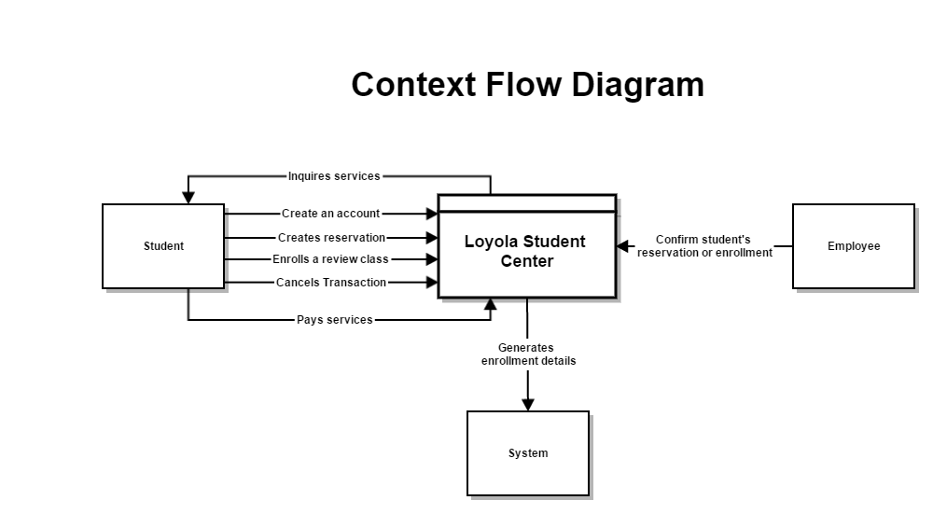

Data Flow Diagram

#### Level 0

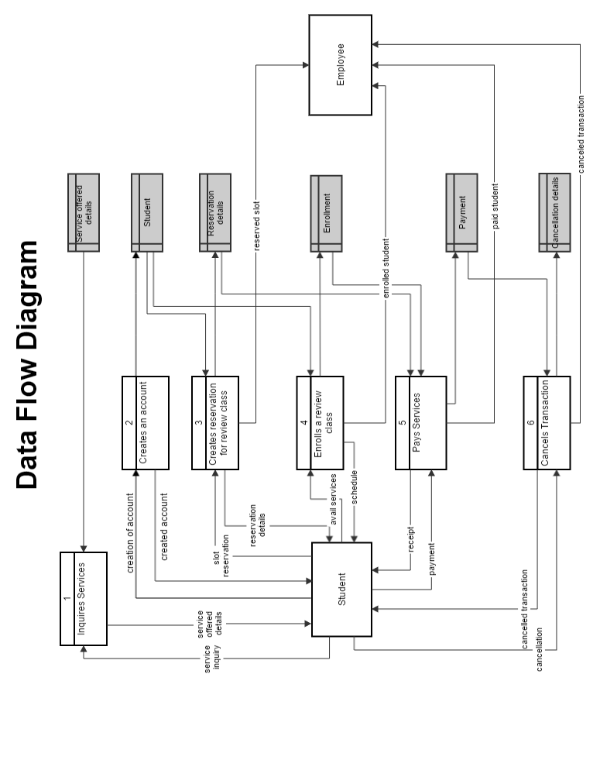

#### Level 1

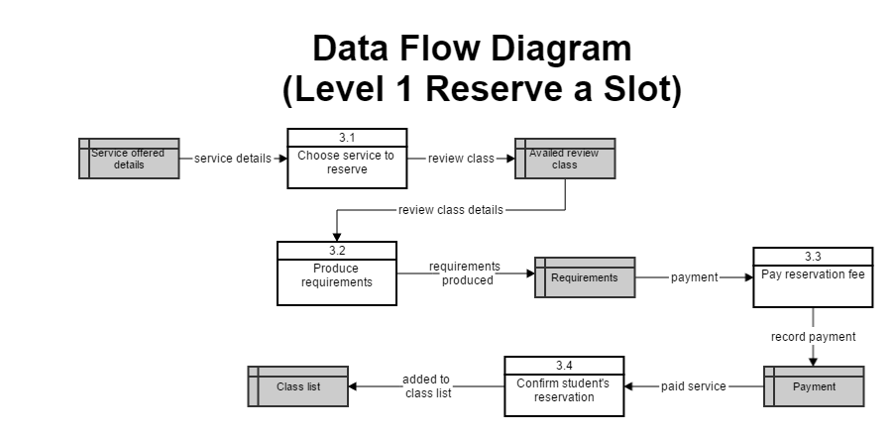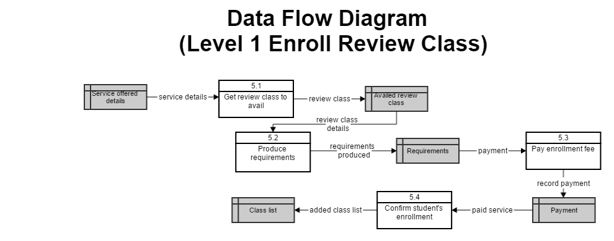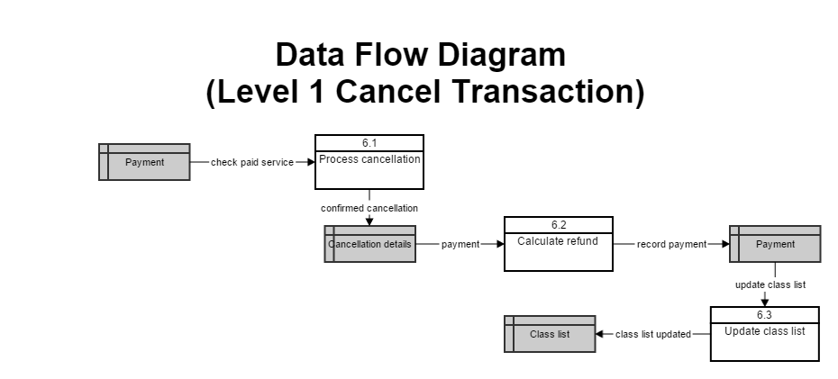

### Entity Relationship Diagram

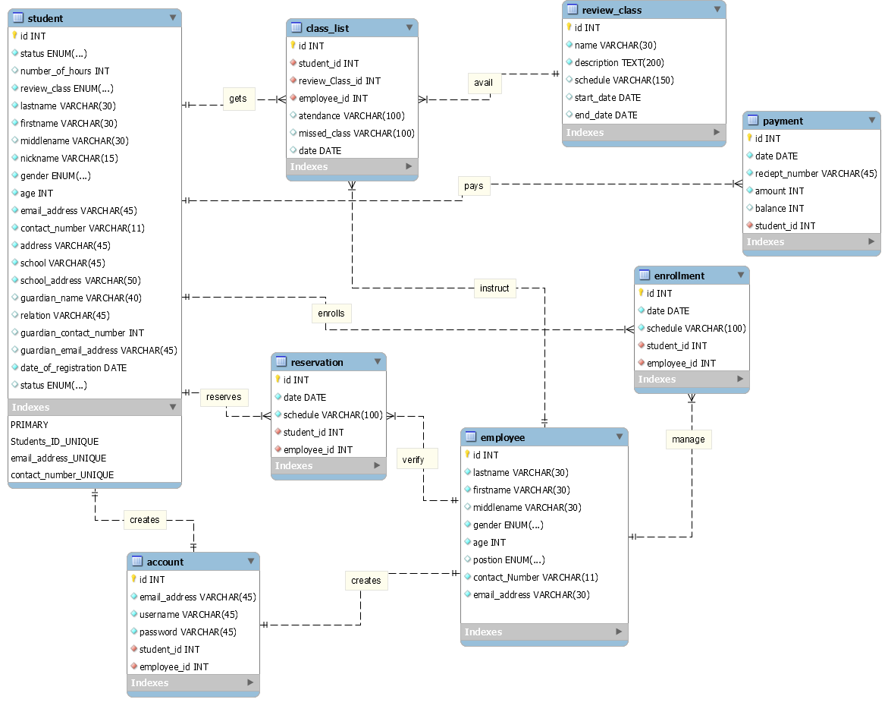

### Use Case Diagram

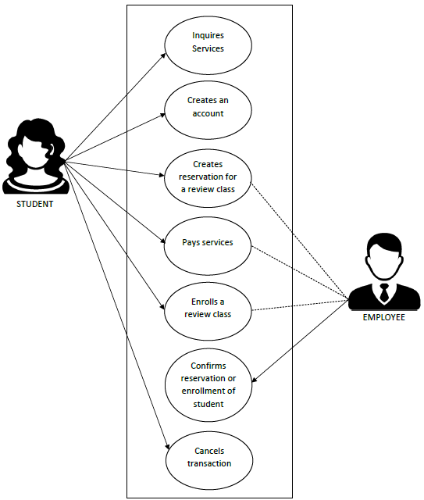

### UML Diagrams

#### Communication Diagram

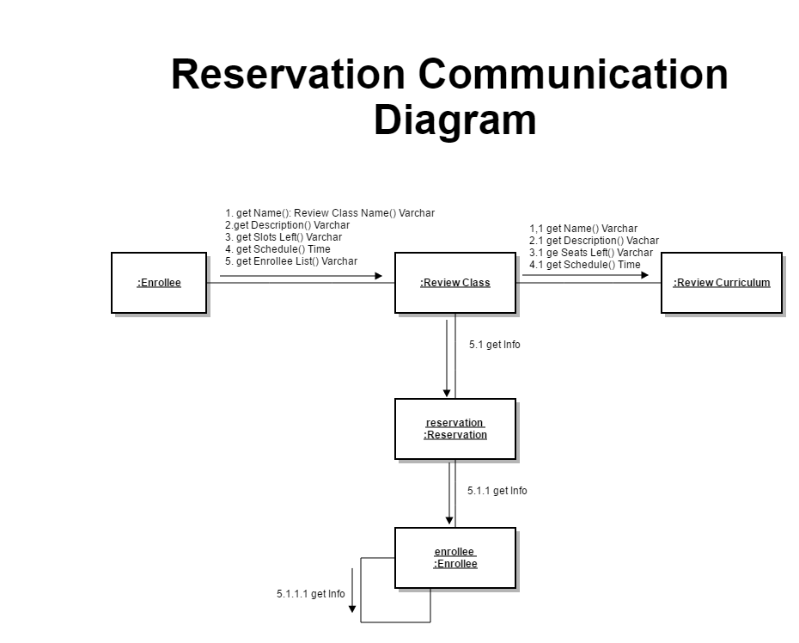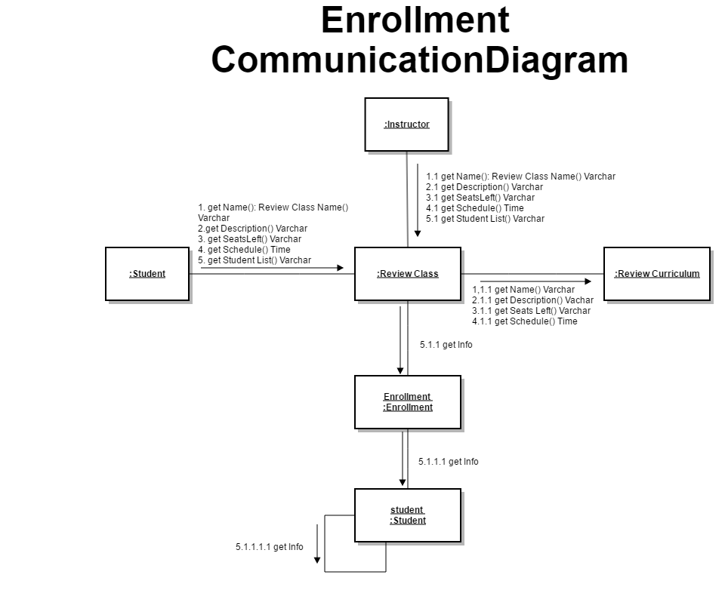

#### Object Diagram

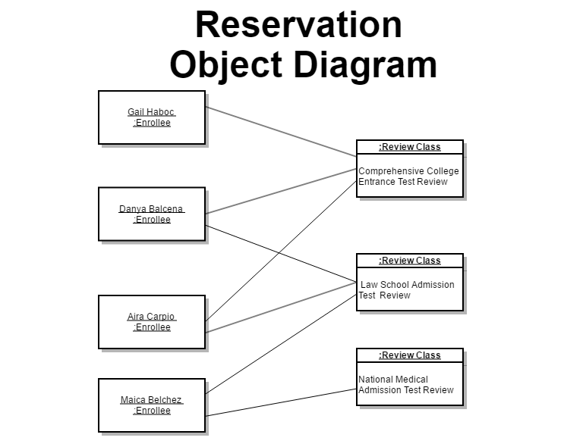

#### State Machine Diagram

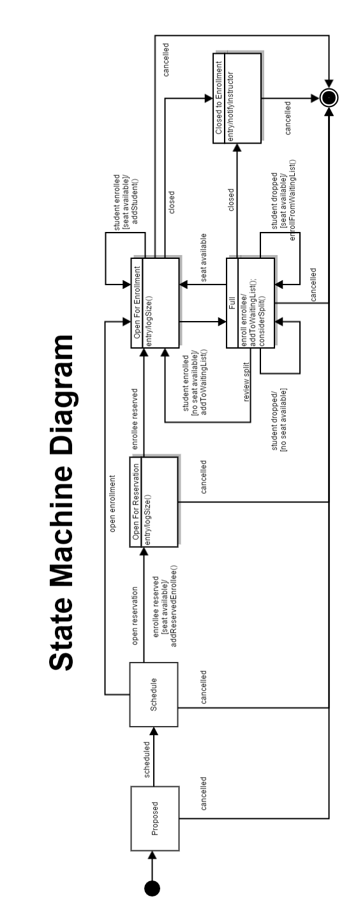

#### Timing Diagram

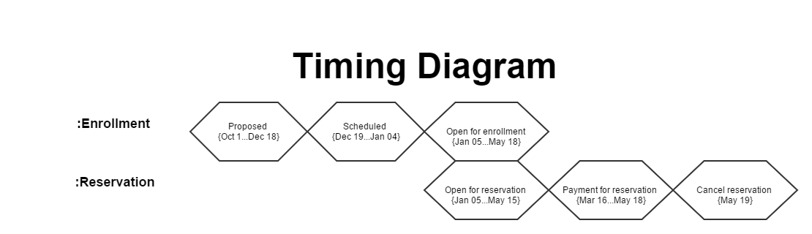

### Class Diagram

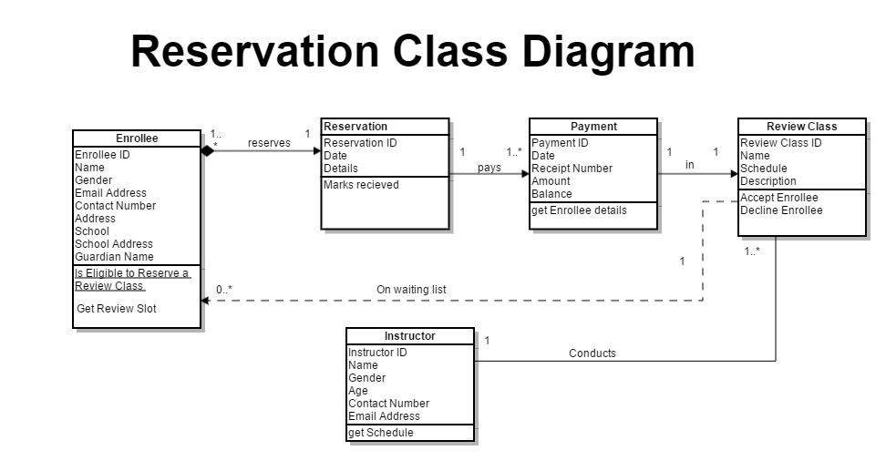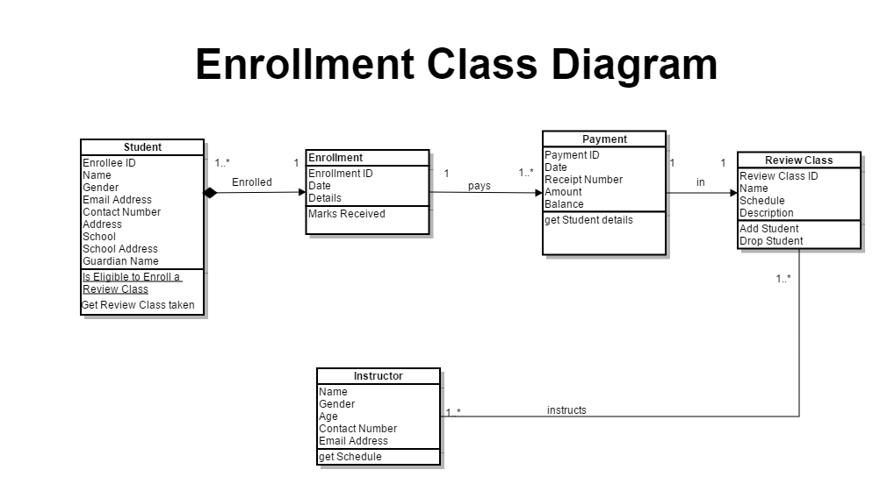

### Sequence Diagram

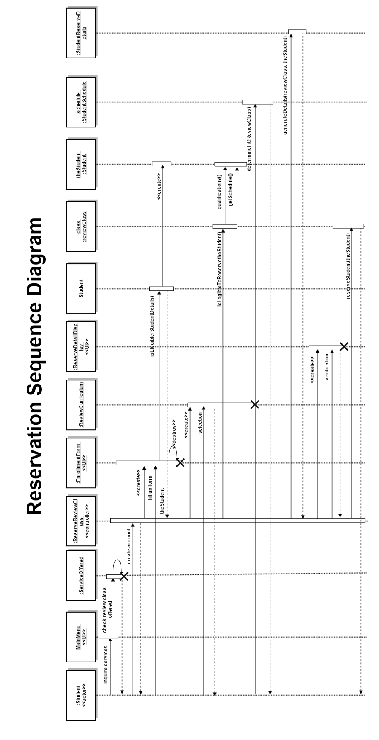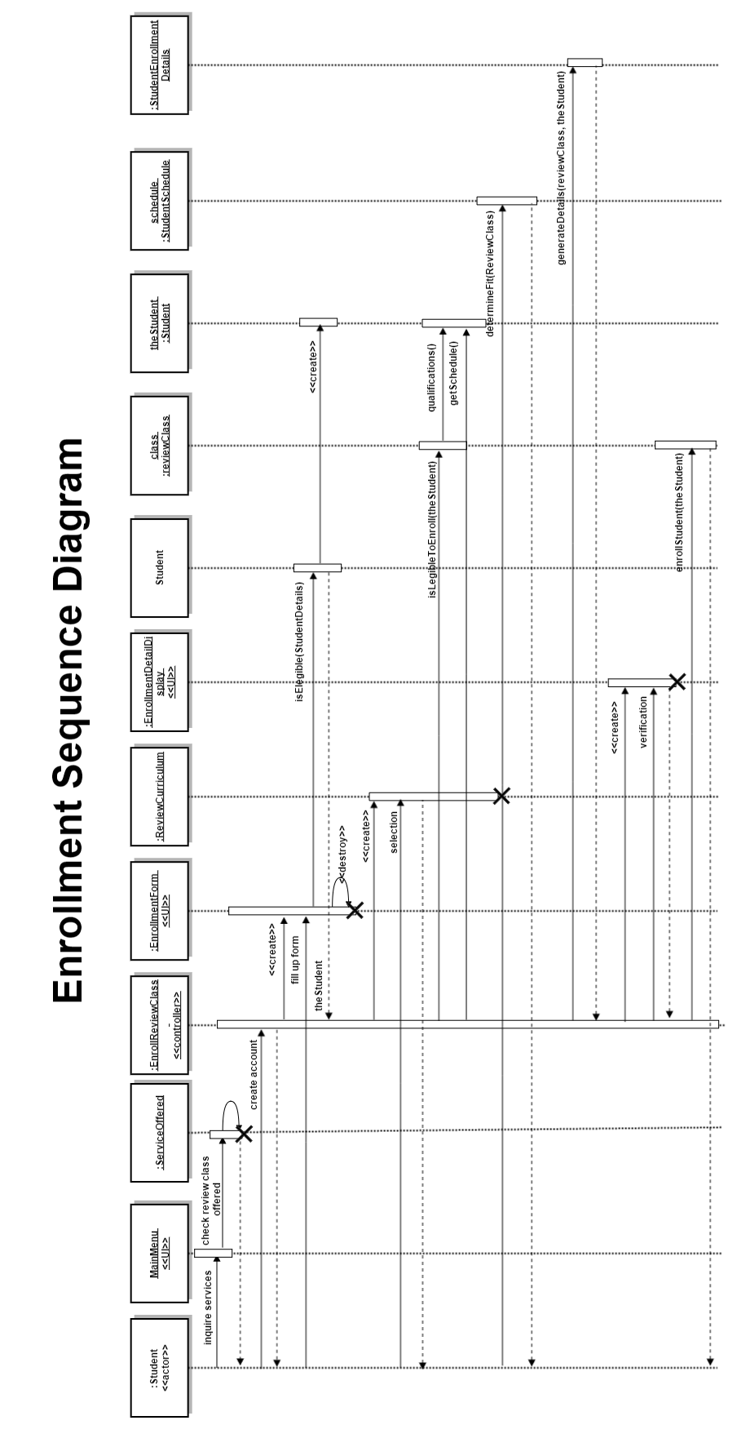

### Package Diagram

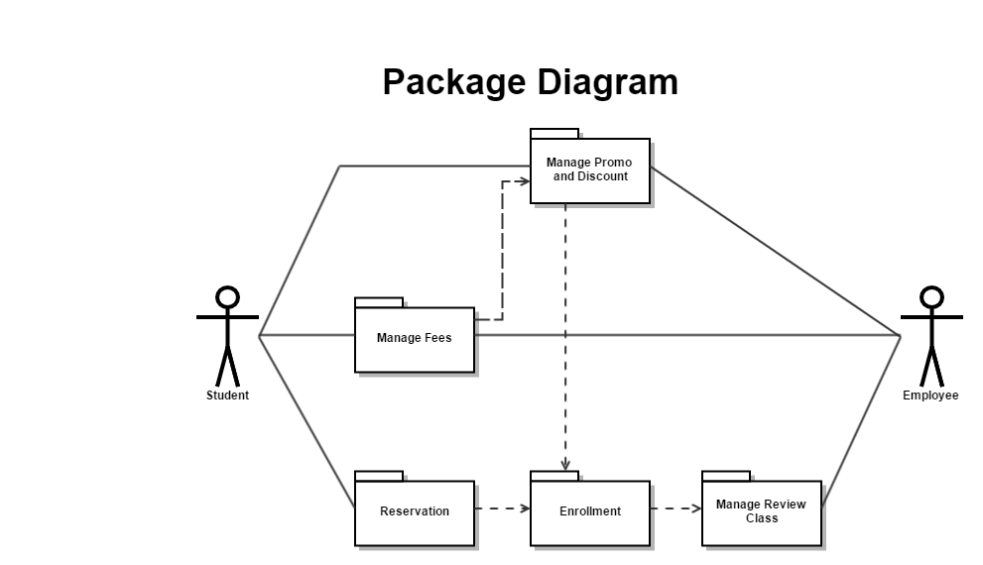

### Deployment Diagram

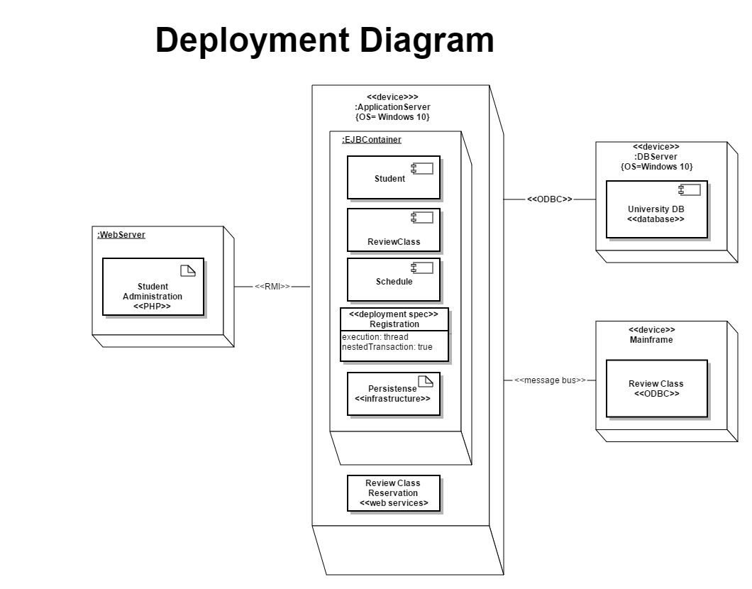

### Activity Diagram

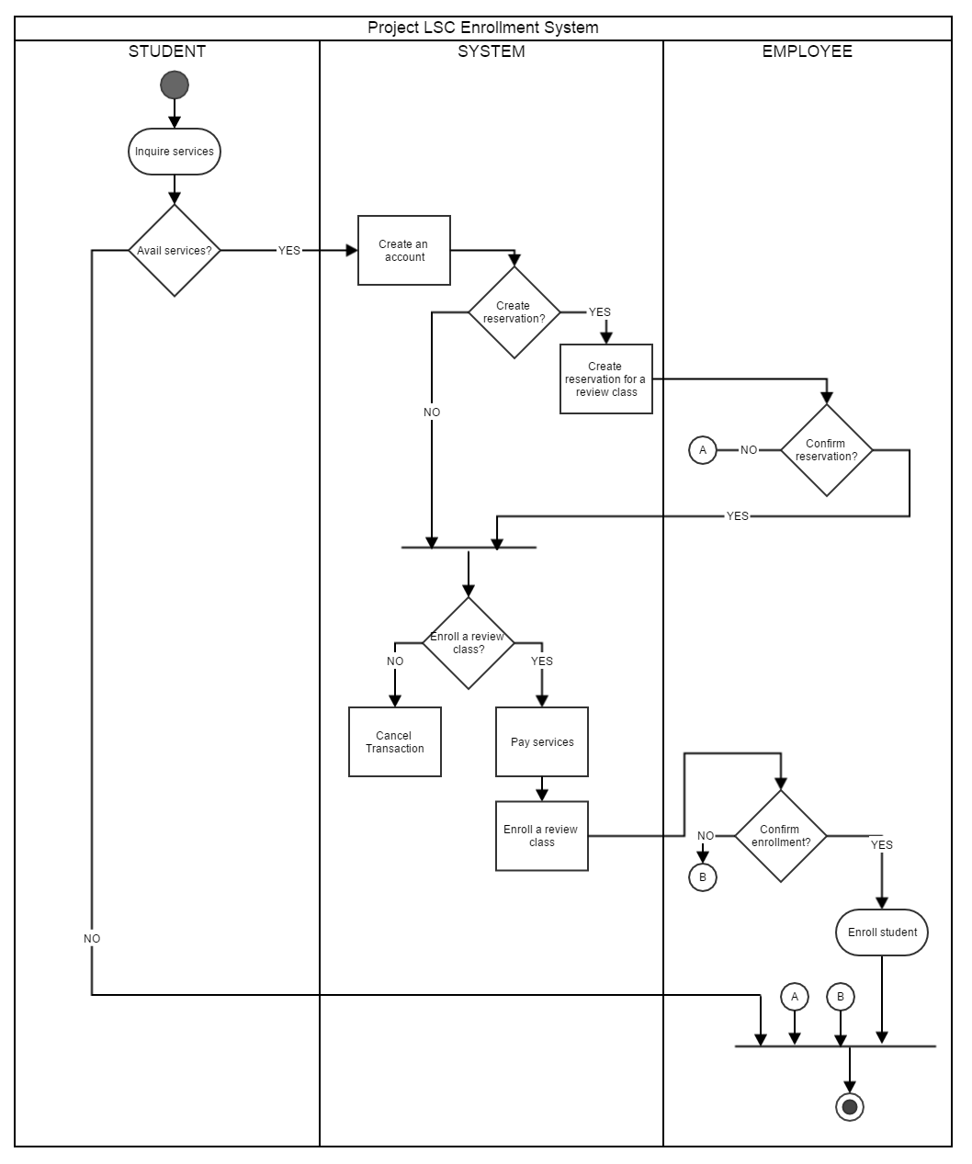

### Component Diagram

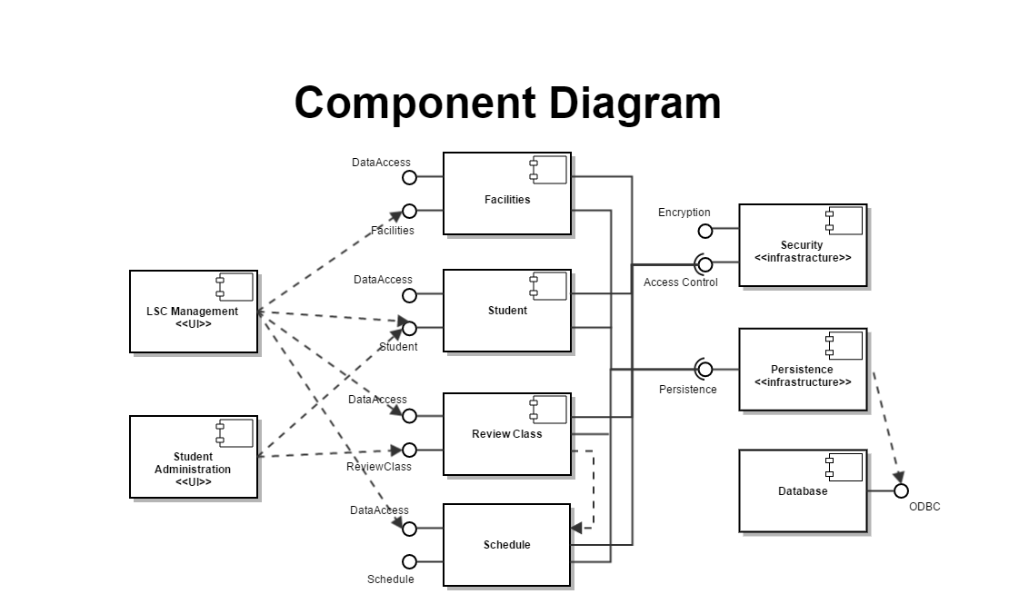

### Composite Structure Diagram

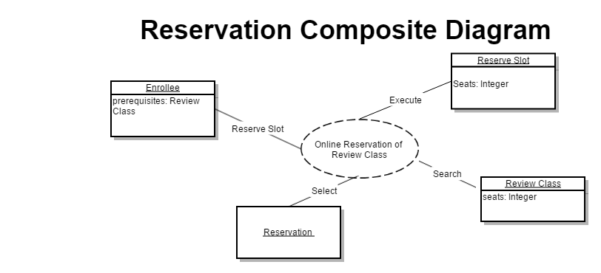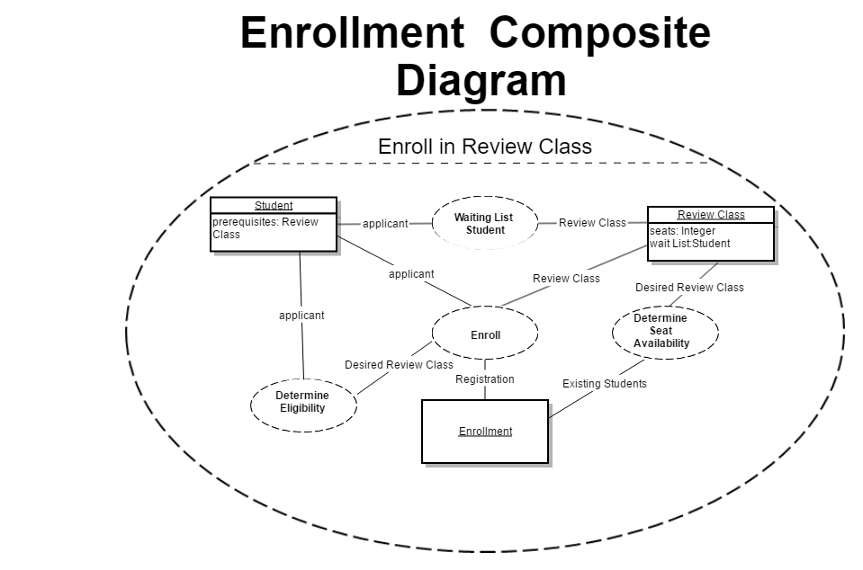

### Interaction Overview Diagram

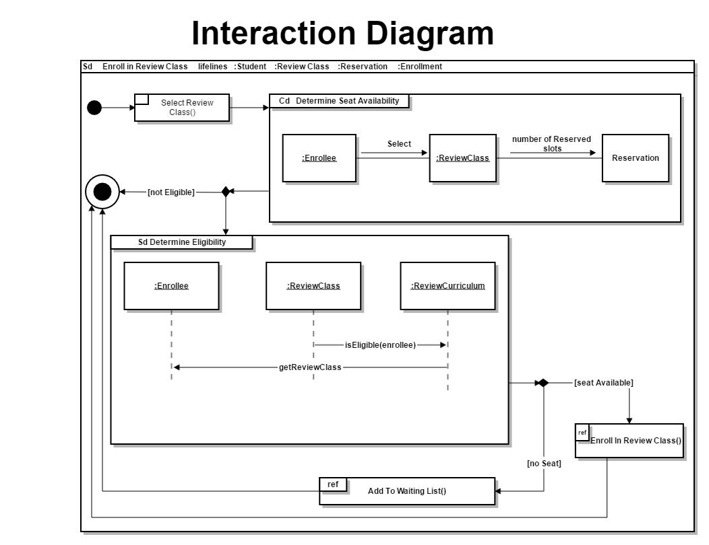

## 6.4 Users Guide

## 6.5 Process/Data/Information Flow

## 6.6 Screen layouts

## 6.7 Test Results

## 6.8 Sample Generated Outputs

## 6.9 Pictures showcasing the data gathering, investigation done (e.g. floor plan, layout, building, etc.)

## 6.10 One-Page Curriculum Vitae per team member

**DANYA PATEÑO BALCENA**

Villa Paraiso 1 Barangay Sun Valley Parañaque City

dpbalcena@gmail.com

09204936472

**EDUCATIONAL BACKGROUND:**

Tertiary

Asia Pacific College

Magallanes, Makati City

Bachelor of Science in Information Technology (undergraduate)

June, 2014-Present

Secondary

Sun Valley Montessori Foundation Inc.

Parañaque City

2010-2014

Elementary

Kalayaan Elementary School

Pasay City

2004-2010

**ORGANIZATIONS:**

Junior Philippine Computer Society -APC

Director of events

Asia Pacific College

Magallanes, Makati City

APC Microsoft Community

Member

Asia Pacific College

Magallanes, Makati City

Junior Information System Security Association

Member

Asia Pacific College

Magallanes, Makati City

**RELATED SKILLS:**

Technical Skills (MS Word, Excel, PowerPoint, Use of Internet search engines, Email)

**CHARACTER REFERENCES:**

Mr. Christian Fruto (Academic)

College Instructor

Asia Pacific College

09467553600

Michelle Gustillo (Academic)

Teacher (Sun Valley Montessori Foundation Inc.)

Parañaque City

09170538574

**AIRA JOYCE ANUNSENCION CARPIO**

Block 19 Lot 17 Twin Pioneer Street, Don Carlos Village, Pasay City aacarpio@student.apc.edu.ph

09151582062

**EDUCATIONAL BACKGROUND:**

Tertiary

Asia Pacific College

#3 Humabon Place, Magallanes, Makati City

Bachelor of Science in Information Technology

Major in Mobile in Internet Technology

June, 2014-Present

Secondary

Pasay City North High School

Tramo Street, Barangay 57, Pasay City, Metro Manila

2010-2014

Elementary

Cuneta Elementary School

2965 Park Avenue Barangay 79 Pasay City Metro Manila

2004-2010

**ORGANIZATIONS:**

Teatre Phileo

Finance Officer

Asia Pacific College

#3 Humabon Place, Magallanes, Makati City

Junior Philippine Computer Society

Committee of Finance Officer

Asia Pacific College

#3 Humabon Place, Magallanes, Makati City

Teatro Norte

Fourth Year Representative

Pasay City North High School

Tramo Street, Barangay 57, Pasay City, Metro Manila

**RELATED SKILLS:**

Operating Computers

Research Writing

Technical Skills (MS Word, Excel, PowerPoint, Use of Internet search engines, Email)

**CHARACTER REFERENCES:**

Mr. Christian Fruto

College Instructor

Asia Pacific College

09467553600

Mr. Joey Hernandez Jr.

President, Teatre Phileo

Asia Pacific College

09123456767

Ms. Alaine Lawrence Hernandez

ABASOC Vice President

PATTS College of Aeronautics

09174368011

**FLORENCE GAIL GUMOGDA HABOC**

11th Avenue, HHSG, North Signal Village, Taguig City

fghaboc@gmail.com

09179398586

**EDUCATIONAL BACKGROUND:**

Tertiary

Asia Pacific College

Magallanes, Makati City

Bachelor of Science in Information Technology Major in Mobile and Internet (undergraduate)

April, 2016-Present

Secondary

Diosdado Macapagal High School

North Signal Village, Taguig City

2010 – 2014

Elementary

Royal Era Academy

North Signal Village, Taguig City

2004 – 2010

**ORGANIZATIONS:**

Junior Philippine Computer Society

Member

Asia Pacific College

Magallanes, Makati City

APC Microsoft Community

Event Committee

Asia Pacific College

Magallanes, Makati City

Junior Information System Security Association

Member

Asia Pacific College

Magallanes, Makati City

**RELATED SKILLS:**

Research Writing Skills

Technical Skills (MS Word, Excel, PowerPoint, Use of Internet search engines, Email)

Programming Skills (Java, PHP, HTML5, Visual Basic)

**CHARACTER REFERENCES:**

Ms. Rosa Haboc

Taguig City, Metro Manila

Contact no.: 0946 755 3600

Email: rosahaboc@yahoo.com

Ms. Phime Haboc

Student

Global City Innovative College

Makati City, Metro Manila

Contact no.: 0908 962 1404

Email: phimhaboc@gmail.com

Ms. Aira Joyce Carpio

Student

Asia Pacific College

Makati City, Metro Manila

Contact no.: 0917 947 1364

Email: aacarpio@student.apc.edu.ph